

SIMATS ENGINEERING

Saveetha Institute of Medical and Technical Sciences
Chennai- 602105

Student Name: G. Hari Prasad Reg. No.: 192525273
Course Code: CSA0604 Slot: B
Course Name: Design and Analysis of Algorithms
Course Faculty: Dr M Manikandan
Project Title: SMART EV CHARGING STATION QUEUE AND SLOT SCHEDULING SYSTEM
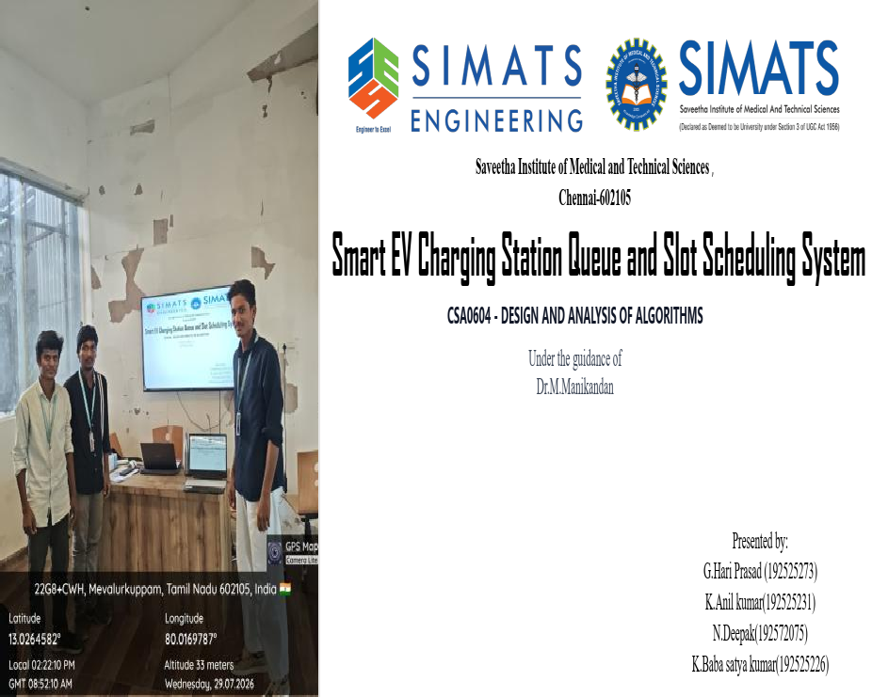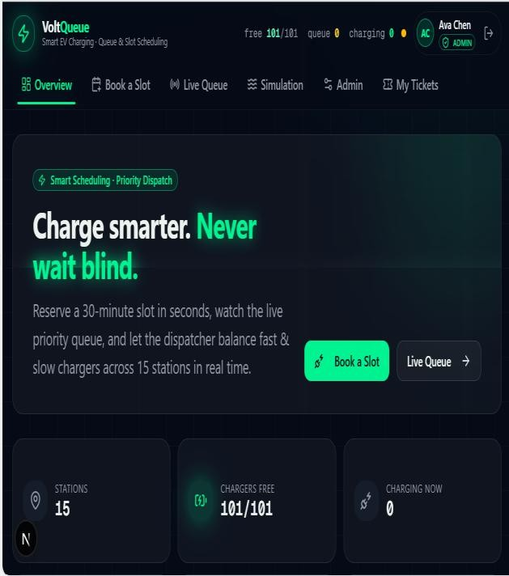
Project Description: (here you write what you did in this project (contribution) including Model Description
Smart EV Charging Station Queue and Slot Scheduling System is a web-based system developed to organize and manage electric vehicle charging services efficiently when the number of charging slots is limited. The system maintains user details, vehicle information, charging station details, slot availability, and charging requests in a structured database. A queue-based scheduling approach is used to manage requests when charging slots are occupied, helping maintain an organized sequence of service and better resource utilization.
The project is divided into four major modules: User & Vehicle Management, Charging Station Management, Queue & Slot Scheduling, and Dashboard & Reports. My individual contribution is Module 1 – User & Vehicle Management, which focuses on user registration, login and authentication concepts, profile management, vehicle registration, vehicle updating and deletion, input validation, and database persistence. The module establishes the relationship between users and their vehicles and provides the required information for submitting charging requests. The complete system is intended to provide a simple and efficient platform for managing EV charging resources while supporting future extensions such as real-time monitoring, mobile notifications, cloud deployment, OCPP integration, and advanced scheduling.

